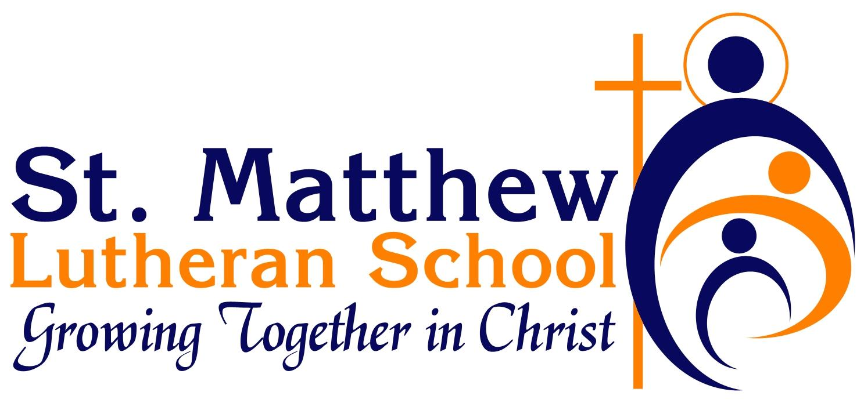

Phase 5
COVID-19 Preparedness
Return to School Plan 2020 - 2021

Lutheran School Families, Educators, and Friends,
We hope you are enjoying your summer and staying safe during this challenging time. We know many of you have questions about what school will look like this fall, and we appreciate your patience and understanding as we look to make sound decisions on what is best for our Lutheran schools and all those we serve.
Your favorite administrators and school leaders have been wrestling with all the items pertaining to school opening this fall and what that means for students, teachers, and parents. The governor’s office has shared the MI Safe Start Plan that has guided our discussions and has required several protocols our schools must follow. The following document is intended to outline the plan for your local Lutheran school for Phase 4 and 5.
I am grateful for the collaboration among our Lutheran school principals as well as our partnerships within the Michigan Association of Nonpublic Schools (MANS). It is reassuring to know we are supported by our brothers and sisters in our parochial schools throughout the state.
We will continue to boldly pray that the Good Lord works a miracle and eradicates this virus from our communities, country, and the world. And at the same time, we will rely on Him for guidance, wisdom, and peace as we move through these ever-changing times. God’s richest blessings on the upcoming school year, and may His love continue to flow to us and through us no matter the circumstances!
Serving Him,
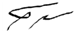
Travis Grulke
Superintendent of Schools
Michigan District, LCMS

Phase 5
COVID-19 Preparedness
Return to School Plan 2020 - 2021

PLEASE NOTE THAT ALL DETAILS CONTAINED IN THIS RETURN TO SCHOOL PLAN ARE SUBJECT TO CHANGE DUE TO NEW INFORMATION AND/OR CIRCUMSTANCES

Personal Protective Equipment

- Face coverings are optional for K - 5 students when in classrooms. Students in grades 6 - 8 and all staff will wear masks in classrooms. If a staff member or student has been identified to be at increased risk of illness by their physician, face covering should be worn.

- All passengers and drivers will wear facial coverings when on a school bus, except (1) when eating and (2) unless face coverings cannot be medically tolerated as documented through written and signed verification by a physician, with parental consent.

- All staff and all students in grades pre-Kindergarten and up will wear facial coverings when in indoor hallways and common areas, except (1) during meals and (2) unless face coverings cannot be medically tolerated as documented through written and signed verification by a physician, with parental consent for students.

- St. Matthew Lutheran School will not conduct indoor assemblies that bring together more students than the most recent Executive Order allows.

- Chapel worship services will follow established St. Matthew worship protocol and will occur with proper six foot distancing and masks.

Hygiene

- Provide adequate supplies to support healthy hygiene behaviors (including soap, hand sanitizer with at least 60% alcohol for safe use by staff and students, paper towels, tissues, and signs reinforcing proper handwashing techniques).

- Systematically and frequently check and refill soap and hand sanitizers.

- Daily provide opportunities for handwashing with soap and water by students and teachers.

- Limit sharing of personal items and supplies such as writing utensils.

Spacing, Movement, and Access

- Space students as far apart as feasible in classrooms, whether desks or tables are utilized.

- Post signage to indicate proper social distancing.

- Place markers at six-foot intervals where line formation is anticipated.

- Provide social distancing markers in waiting and reception areas.

- Post signs on the doors of restrooms to indicate proper social distancing and hand hygiene techniques.

- On school days and during school hours, restrict entrance to the building to students and staff only, with exception of approved ministries and extenuating circumstances. All non-staff adults entering the building will follow social-distance state recommendations and must be screened for symptoms using a monitoring form, wear a facial covering, and wash/sanitize hands prior to entering. Strict records, including date and time, should be kept on all non-staff adults entering and exiting the building.

Screening Students and Staff

- Staff should conduct daily self-examinations, including a temperature check, prior to coming to work. If they exhibit any respiratory or gastrointestinal symptoms or have a temperature of 100.4 or greater, they should stay home. Staff member will contact the school administrator.

- Daily screening is required using the Staff and Student Screening Checklist, or a virtual equivalent.

- It is strongly recommended that daily temperature checks are included in the screening for all adults.

Student Screening

AT HOME:
- Every parent/guardian must submit a COVID-19 School Health Screening Acknowledgment form prior to start of school year.

- Parents/guardians must screen daily for symptoms at home, prior to boarding the bus and arrival at school using the Staff and Student Screening Checklist.

- Students and staff who become ill with signs or symptoms of COVID-19 will be placed in an identified quarantine area with a facial covering in place, if able, until they can be picked up. Identified person caring for these children/staff should wear a surgical mask.

- Staff and parent/guardian of the student should call their preferred health care provider for guidance.

- Symptomatic students and staff sent home from school will stay home until they
have tested negative or have completely recovered according to CDC guidelines.

Testing Protocols for Students and Staff and Responding to Positive Cases

- Symptomatic students and staff will be kept home until they have tested negative for COVID-19 or have been released from isolation according to OCHD/CDC guidelines.Both guidelines state:
Students and staff can be around others after:

- 10 days since symptoms first appeared and
- 24 hours with no fever without the use of fever-reducing medications and
- COVID-19 symptoms have improved (for example, cough, shortness of breath)
- Most people do not require testing to decide when they can be around others; however, if your healthcare provider recommends testing, they will let you know when you can resume being around others based on your test results. COVID-19 - When you are sick/end-home-isolation

- Families will be notified of the presence of any laboratory positive or clinically diagnosed cases of COVID-19 in the classroom and/or school to encourage closer observation for any symptoms at home.

Responding to Positive Tests Among Staff and Students

- The following is the process as outlined by the OCHD:
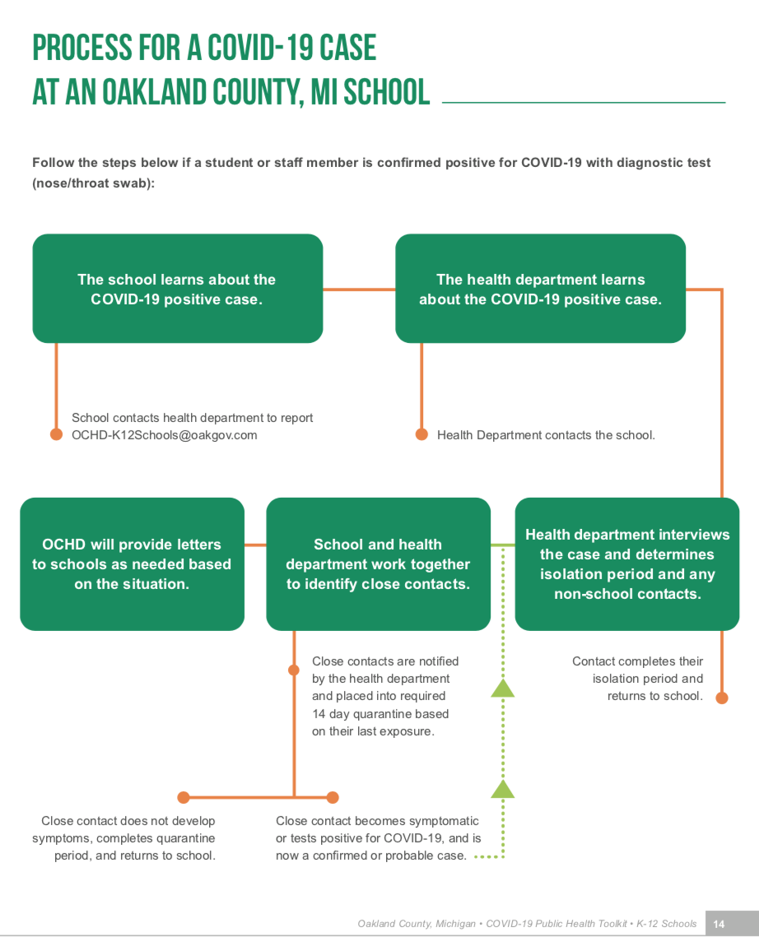

Food Service, Gathering, and Extracurricular Activities

- St. Matthew Lutheran School will not conduct indoor assemblies that bring together more students than the latest Executive Order allows.

- Chapel worship services will follow established St. Matthew worship protocol and will occur with proper six foot distancing and masks.

- Drinking fountains will remain blocked off.

- If cafeterias are used and six feet of distance between students is not possible, mealtimes should be staggered, or physical barriers can be used. Serving and cafeteria staff will use barrier protection including gloves, face shields, and surgical masks.

Athletics

- Schools will comply with all guidance published by Michigan High School Athletic Association (MHSAA) and the National Federation of State High School Associations (NFHS).

- Students, teachers, and staff must use proper hand hygiene techniques before and after every practice, event, or other gathering.

- Every participant should confirm that they are healthy and without any symptoms prior to any event. On non-school days (Saturday tournaments) Monitoring Form needs to be completed by all participants (this includes all adult volunteers, coaches, and administrators). Visiting teams will also be expected to complete same forms.

- All equipment must be disinfected before and after use.

- Each participant must use a clearly marked water bottle for individual use. There should be no sharing of this equipment.

- Handshakes, fist bumps, and other unnecessary contact must not occur.

Cleaning

- Frequently touched surfaces including desks, light switches, doors, benches, bathrooms, and hands on classrooms will undergo frequent cleaning with either an EPA-approved disinfectant or diluted bleach solution.

Busing and Student Transportation (including extra-curricular activities and athletics)

- Students who use public school district busing will defer all safety guidelines to those providers.

- Parents driving for school events will clean and disinfect transportation vehicles before and after every transit route. Children will not be present when a vehicle is being cleaned, and students will wear masks while riding in vehicles.

Mental & Social-Emotional Health

- St. Matthew will establish a point person to facilitate mental health referrals, communications to families/ students, and public-facing wellness materials.

- Provide all staff with timely, responsive, and ongoing training/professional development.

