Phase 4
COVID-19 Preparedness
Return to School Plan 2020 - 2021

August 12, 2020

Dear Parents,

A few weeks ago, the question from the radio announcer asked, “What was one of the most useless purchases this year?” The answer was, “A 2020 Planner!” Our Church Office Manager, Mrs. Gail Adams, has given the staff a great visual reminder of this sentiment. On the wall next to Gail’s desk is a huge 2020 calendar, and down the middle of the months of March, April, May, and June, Gail has placed a note that says, “God had other plans!”

Most of us appreciate a plan, and some of us thrive best when we know the plans in advance. However, sometimes (like last spring!), a curveball occurs, and plans don’t always turn out the way we intended or hoped. During those times, we need to trust God and keep seeking His will, as He encourages us in Proverbs 3:5 & 6 “Trust in the Lord with your whole heart and lean not on your own understanding. And in all of your ways acknowledge Him, and He will make your paths straight.”

Attached is St. Matthew Lutheran School’s Phase 4 “Return To School Plan”. Every school in the State of Michigan is required to submit their personalized “Return To School Plan” following the Governor’s mandates and suggestions as presented in the MI Safe Schools Return To School Roadmap.

A Task Force of sixteen dedicated people with a wide variety of expertise and knowledge served on the St. Matthew Return To School Task Force. Guided by much prayer, they developed St. Matthew’s Phase 4 and Phase 5 Plans, utilizing the most current data and information available. However, knowing how fluid this pandemic is, we realize that new information may necessitate an occasional revision.

Listed below is the MI Safe Start Plan with the various Phases and explanations of each.

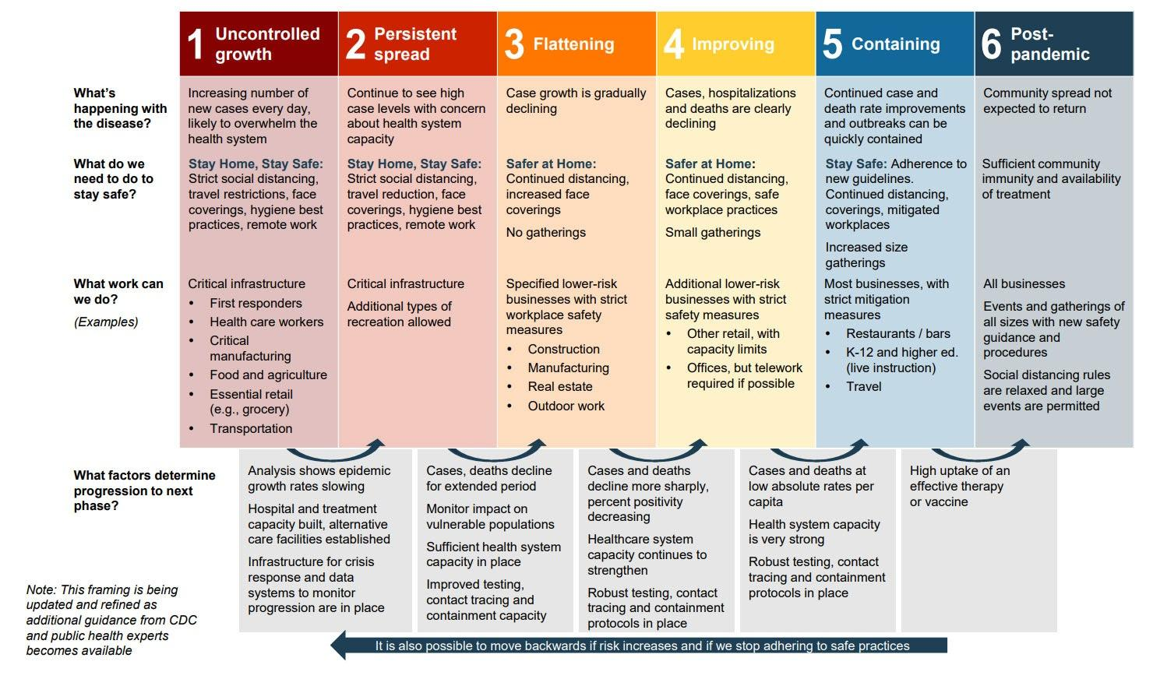

Michigan is currently in Phase 4; that is the plan that we have included for your perusal. In the very near future, we will also send you our Phase 5 Plan as well.

This school year will be different in various ways with new policies and procedures; we pray this will be only temporary. However, the foundation of this school will always remain the same as we build and base everything upon the name of Jesus! Pointing our students to the Lord and enhancing their faith and relationship in Christ will always be the heartbeat of our school, regardless of any circumstance or pandemic, and there is NO impossible with Him!

Rejoicing that we are in His hands,
Mrs. Palka and The St. Matthew Return To School Task Force

Lutheran School Families, Educators, and Friends,
We hope you are enjoying your summer and staying safe during this challenging time. We know many of you have questions about what school will look like this fall, and we appreciate your patience and understanding as we look to make sound decisions on what is best for our Lutheran schools and all those we serve.
Your favorite administrators and school leaders have been wrestling with all the items pertaining to school opening this fall and what that means for students, teachers, and parents. The Governor’s office has shared the MI Safe Start Plan that has guided our discussions and has required several protocols our schools must follow. The following document is intended to outline the plan for your local Lutheran school for Phase 4 and 5.
I am grateful for the collaboration among our Lutheran school principals as well as our partnerships within the Michigan Association of Nonpublic Schools (MANS). It is reassuring to know we are supported by our brothers and sisters in our parochial schools throughout the state.
We will continue to boldly pray that the Good Lord works a miracle and eradicates this virus from our communities, country, and the world. And at the same time, we will rely on Him for guidance, wisdom, and peace as we move through these ever-changing times. God’s richest blessings on the upcoming school year, and may His love continue to flow to us and through us no matter the circumstances!
Serving Him,
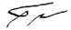
Travis Grulke
Superintendent of Schools
Michigan District, LCMS

Phase 4
COVID-19 Preparedness
Return to School Plan 2020 - 2021

PLEASE NOTE THAT ALL DETAILS CONTAINED IN THIS RETURN TO SCHOOL PLAN ARE SUBJECT TO CHANGE DUE TO NEW INFORMATION AND/OR CIRCUMSTANCES

When Oakland County has been deemed in Phase 4, as described in the MI Safe Start Plan, St. Matthew Lutheran School will adhere to the following procedures:

Personal Protective Equipment

- All staff will wear facial coverings when in classrooms, except (1) during meals and (2) unless face coverings cannot be medically tolerated as documented through written and signed verification by a physician.

- All passengers and drivers will wear facial coverings when on a school bus, or when sharing rides with others not in the same household for school sanctioned events except (1) when eating and (2) unless face coverings cannot be medically tolerated as documented through written and signed verification by a physician, with parental consent.

- All staff and all students will wear facial coverings when in indoor hallways and common areas, except (1) during meals and (2) unless face coverings cannot be medically tolerated as documented through written and signed verification by a physician, with parental consent for students.

- Facial coverings are not required in preschool classrooms by children ages 3 and 4 since they are a licensed Preschool through the State of Michigan and follow licensing laws established by the Michigan Department of Licensing and Affairs (LARA).

- All staff and students in grades K - 8 will wear facial coverings, except (1) during meals and (2) unless face coverings cannot be medically tolerated as documented through written and signed verification by a physician, with parental consent.

- St. Matthew Lutheran School will not conduct indoor assemblies that bring together students from more than one classroom.

- Chapel worship services will begin with an online format. When chapel services resume in person, the service may occur following the established St. Matthew worship protocol and will occur with proper six-foot distancing and masks.

- Facial coverings may be homemade or disposable level one/basic-grade surgical masks. If desired, more information may be found regarding cloth face coverings at the Oakland County Health Department (herein after referred to as OCHD) website.

Hygiene

- Provide adequate supplies to support healthy hygiene behaviors (including soap, hand sanitizer with at least 60% alcohol for safe use by staff and students, paper towels, tissues, and signs reinforcing proper handwashing techniques).

- Teach and reinforce handwashing with soap and water for at least 20 seconds and/or the safe use of hand sanitizer that contains at least 60% alcohol. OCHD Handwashing Guideline

- Educate staff and students on how to cough and sneeze into their elbows, or to cover with a tissue. Used tissues should be thrown in the trash and hands washed immediately using proper hand hygiene techniques.

- Systematically and frequently check and refill soap and hand sanitizer.

- Schedule times for students and teachers for handwashing with soap and water every 2 - 3 hours.

- Limit sharing of personal items and supplies such as writing utensils.

Spacing, Movement, and Access

- Space students as far apart as feasible in classrooms, whether desks or tables are utilized.

- Post signage to indicate proper social distancing.

- Place markers at six-foot intervals where line formation is anticipated.

- Provide social distancing markers in waiting and reception areas.

- Post signs on the doors of restrooms to indicate proper social distancing and hand hygiene techniques.

- On school days and during school hours, restrict entrance to the building to students and staff only, with the exception of approved ministries and extenuating circumstances. All non-staff adults entering the building will follow social-distance state recommendations and must be screened for symptoms using a monitoring form based on the OCHD form Visitor and Vendor Screening Checklist for Schools, wear a facial covering, and wash/sanitize hands prior to entering. Strict records, including date and time, should be kept of all non-staff adults entering and exiting the building.

Screening Students and Staff
- Screening is required before entering the bus (if applicable) or school building. Once an individual arrives at school and they are symptomatic, exposure to students and staff that are close contacts as defined by OCHD have already occurred. Per the OCHD, specific screening requirements are outlined below.
Staff and Administration Screening

- Staff should conduct daily self-examinations, including a temperature check, prior to coming to work. If they exhibit any respiratory or gastrointestinal symptoms or have a temperature of 100.4 or greater, they should stay home. Staff member will contact the school administrator.

- Daily screening is required using the Staff and Student Screening Checklist, or a virtual equivalent.

- It is strongly recommended that daily temperature checks are included in the screening for all adults.

Student Screening

AT HOME:
- Every parent/guardian must submit a COVID-19 School Health Screening Acknowledgment form prior to start of school year.

- Parents/guardians must screen daily for symptoms at home, prior to boarding the bus and arrival at school using the Staff and Student Screening Checklist.

- Students and staff who become ill with signs or symptoms of COVID-19 will be placed in an identified quarantine area with a facial covering in place, if able, until they can be picked up. Identified person caring for these children/staff should wear a surgical mask.

- Staff and parent/guardian of the student should call their preferred health care provider for guidance.

- Symptomatic students and staff sent home from school will stay home until they
have tested negative or have completely recovered according to CDC guidelines.

Testing Protocols for Students and Staff and Responding to Positive Cases

- Symptomatic students and staff will be kept home until they have tested negative for COVID-19 or have been released from isolation according to OCHD/CDC guidelines.Both guidelines state:
Students and staff can be around others after:

- 10 days since symptoms first appeared and
- 24 hours with no fever without the use of fever-reducing medications and
- COVID-19 symptoms have improved (for example, cough, shortness of breath)
- Most people do not require testing to decide when they can be around others; however, if your healthcare provider recommends testing, they will let you know when you can resume being around others based on your test results. COVID-19 - When you are sick/end-home-isolation
- Families will be notified of the presence of any laboratory positive or clinically diagnosed cases of COVID-19 in the classroom and/or school to encourage closer observation for any symptoms at home.

Responding to Positive Tests Among Staff and Students

- The following is the process as outlined by the OCHD:
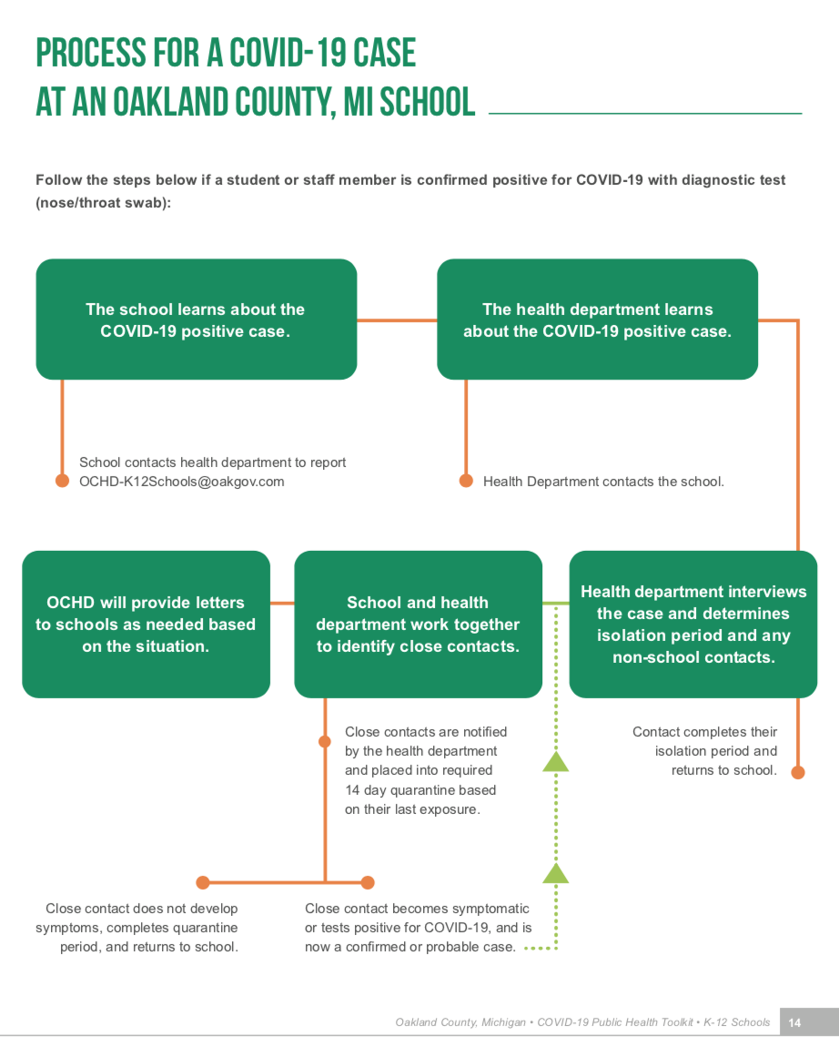

Food Service, Gathering, and Extracurricular Activities

- Prohibit indoor assemblies that bring together students from more than one classroom.

- If cafeterias are used and six feet of distance between students is not possible, meal times should be staggered or physical barriers should be used. Serving and cafeteria staff will use barrier protection including gloves, face shields, and surgical masks.

- Classrooms and outdoor areas will be used for students to eat meals at school.

Athletics

- St. Matthew Lutheran School will comply with all guidance published by Michigan High School Athletic Association (MHSAA) and the National Federation of State High School Associations (NFHS).

- Students, teachers, and staff must use proper hand hygiene techniques before and after every practice, event, or other gathering.

- Every participant should confirm that they are healthy and without any symptoms prior to any event utilizing the OCHD form Staff and Student At-Home Screening Checklist.

- All equipment must be disinfected before and after use.

- Each participant must use a clearly marked water bottle for individual use. There should be no sharing of this equipment.

- Handshakes, fist bumps, and other unnecessary contact must not occur.

- Outdoor physical conditioning activities are allowed while maintaining social distancing.

- Large scale indoor spectator events are suspended. Large scale outdoor spectator or stadium events are limited to 100 people, and people not part of the same household must maintain six feet of distance from one another.

- Spectators are allowed provided that facial coverings are used by observers and six feet of social distancing can be maintained at all times. Attention must be given to entry and exit points to prevent crowding.

Cleaning

- Frequently touched surfaces including light switches, doors, benches, bathrooms, will undergo cleaning at least every four hours with either an EPA-approved disinfectant or diluted bleach solution.

- Libraries, computer labs, arts, and other hands-on classrooms will undergo cleaning after every class period with either an EPA-approved disinfectant or diluted bleach solution.

- Student desks will be wiped down with either an EPA-approved disinfectant or diluted bleach solution after every class.

- Playground structures will continue to undergo normal routine cleaning, but using an EPA-approved disinfectant is unnecessary.

- Ensure safe and correct use and storage of cleaning and disinfection products, including storing products securely away from children, and with adequate ventilation when staff use products.

- Staff must wear gloves, surgical masks, and face shields when performing all cleaning activities.

Busing and Student Transportation (including extra-curricular activities and athletics)
(The State of Michigan is requiring the following protocol for schools providing bus transportation. St. Matthew does not directly provide bus transportation but there are St. Matthew students that utilize Walled Lake bus services. As a result, we have included these requirements in our plans so that all parents are aware of the required protocols. All St. Matthew students will need to follow the guidelines established by Walled Lake Transportation.)

- Require the use of hand sanitizer before entering the bus. Hand sanitizer must be supplied on the bus.

- The bus driver, staff and all students in grades PreK-12, if medically feasible, must wear facial coverings while on the bus. Note: there may be situations where it is not safe for the bus driver to wear a facial covering. Decisions about these situations should be made on a case by case basis with local public health officials.

- Clean and disinfect transportation vehicles before and after every transit route. Children must not be present when a vehicle is being cleaned.

- Clean and disinfect frequently touched surfaces in the vehicle (e.g. surfaces in the driver’s cockpit, hard seats, arm rests, door handles, seat belt buckles, light and air controls, doors and windows, and grab handles) prior to morning routes and prior to afternoon routes.

- Clean, sanitize, and disinfect equipment including items such as car seats, wheelchairs, walkers, and adaptive equipment being transported to schools daily.

- Create a plan for getting student home safely if they are not allowed to board the vehicle.

- If a student becomes sick during the day, they will not use group transportation to return home and must follow protocols outlined above. If a driver becomes sick during the day, they will follow protocols for sick staff outlined above and will not return to drive students.

- Weather permitting, doors and windows will be open when cleaning the vehicle and between trips to let the vehicles thoroughly air out.

- Weather permitting, consider keeping windows open while the vehicle is in motion to help reduce the spread of the virus by increasing air circulation, if appropriate and safe.

Mental & Social-Emotional Health

- St. Matthew will identify a point person or establish an access navigator to facilitate mental health referrals, communications to families/ students, and public-facing wellness materials.

- Provide all staff with timely, responsive, and ongoing training/professional development.

RESOURCES
General
Executive Order: EO 2020-142.pdf
Roadmap: MI Safe Schools Return to School Roadmap
Centers for Disease Control and Prevention (CDC): Coronavirus (COVID-19): www.cdc.gov/coronavirus/2019-nCoV
State of Michigan: COVID-19 Response: https://www.michigan.gov/mde/0,4615,7-140-37818_53456---,00.html
CDC: Resources for Childcare, Schools, and Youth Programs: https://www.cdc.gov/coronavirus/2019-ncov/community/schools-childcare/index.html
Federal OSHA: www.osha.gov
American Academy of Pediatrics: https://services.aap.org/en/pages/2019-novel-coronavirus-covid-19-infections/clinical-guidance/covid-19-planning-considerations-return-to-in-person-education-in-schools/?fbclid=IwAR2AUmBlU9Q8ZwmQz7nqQR_BHCiYojgVHbTooQDnFSU_c0bie6QWzt3pSY4.
Oakland Count Toolkit for K-12 Schools: https://www.oakgov.com/covid/resources/education/Documents/Education%20Toolkit.pdf

Hygiene
Handwashing video translated into multiple languages: www.youtube.com/watch?v=LdQuPGVcceg
CDC Prevention: www.cdc.gov/coronavirus/2019-ncov/prevent-getting-sick/prevention.html
CDC Hygiene Etiquette: www.cdc.gov/healthywater/hygiene/etiquette/coughing_sneezing.html

Housekeeping
CDC Disinfecting: www.cdc.gov/coronavirus/2019-ncov/community/disinfecting-building-facility.html
CDC Cleaning: www.cdc.gov/coronavirus/2019-ncov/community/organizations/cleaning-disinfection.html
Environmental Protection Agency (EPA): www.epa.gov/pesticide-registration/list-n-disinfectants-use-against-sars-cov-2

Employees Exhibiting Signs and Symptoms of COVID-19
CDC Sickness Steps: www.cdc.gov/coronavirus/2019-ncov/if-you-are-sick/steps-when-sick.html

OSHA Training
Federal OSHA: www.osha.gov/Publications/OSHA3990.pdf

Social Distancing
CDC: https://www.cdc.gov/coronavirus/2019-ncov/community/guidance-business-response.html
Social Distancing Calculator: https://www.banquettablespro.com/social-distancing-room-space-calculator

Mental Health
Christie Hansard, Michigan District - LCMS
Mental Health Case Manager / Parish Nurse Ministries
734.845.2972

